**NAME – KHUSHI PANWAR**

**PYTHON (DATA SCIENCE) PRACTICAL LIST**

1. **Write a PYTHON program to find maximum between two numbers.**

print("\n\n\t ** PYTHON PROGRAM ** \n")

num1=float(input("Enter the first number : "))

num2=float(input("Enter the second number : "))

if num1>num2:

    print(num1 , "is greater than ", num2)

else:

    print(num2 , "is greater than ", num1)

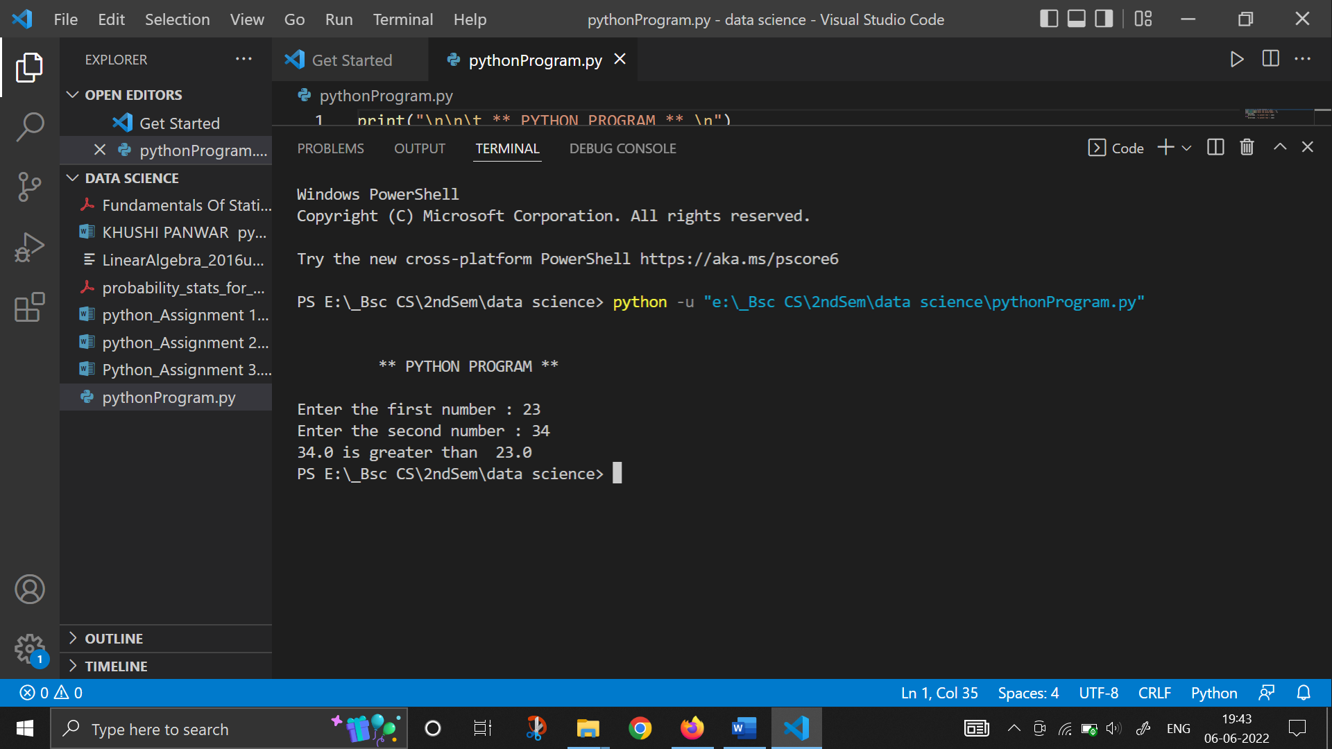

1. **Write a PYTHON program to find maximum between three numbers.**

print("\n\n\t ** PYTHON PROGRAM ** \n")

num1=float(input("Enter the first number : "))

num2=float(input("Enter the second number : "))

num3=float(input("Enter the third number : "))

max=num3

if num1>max:

    max=num1

elif num2>max:

    max=num2

else:

    max=num3

print()

print(max, "is the greatest number!")

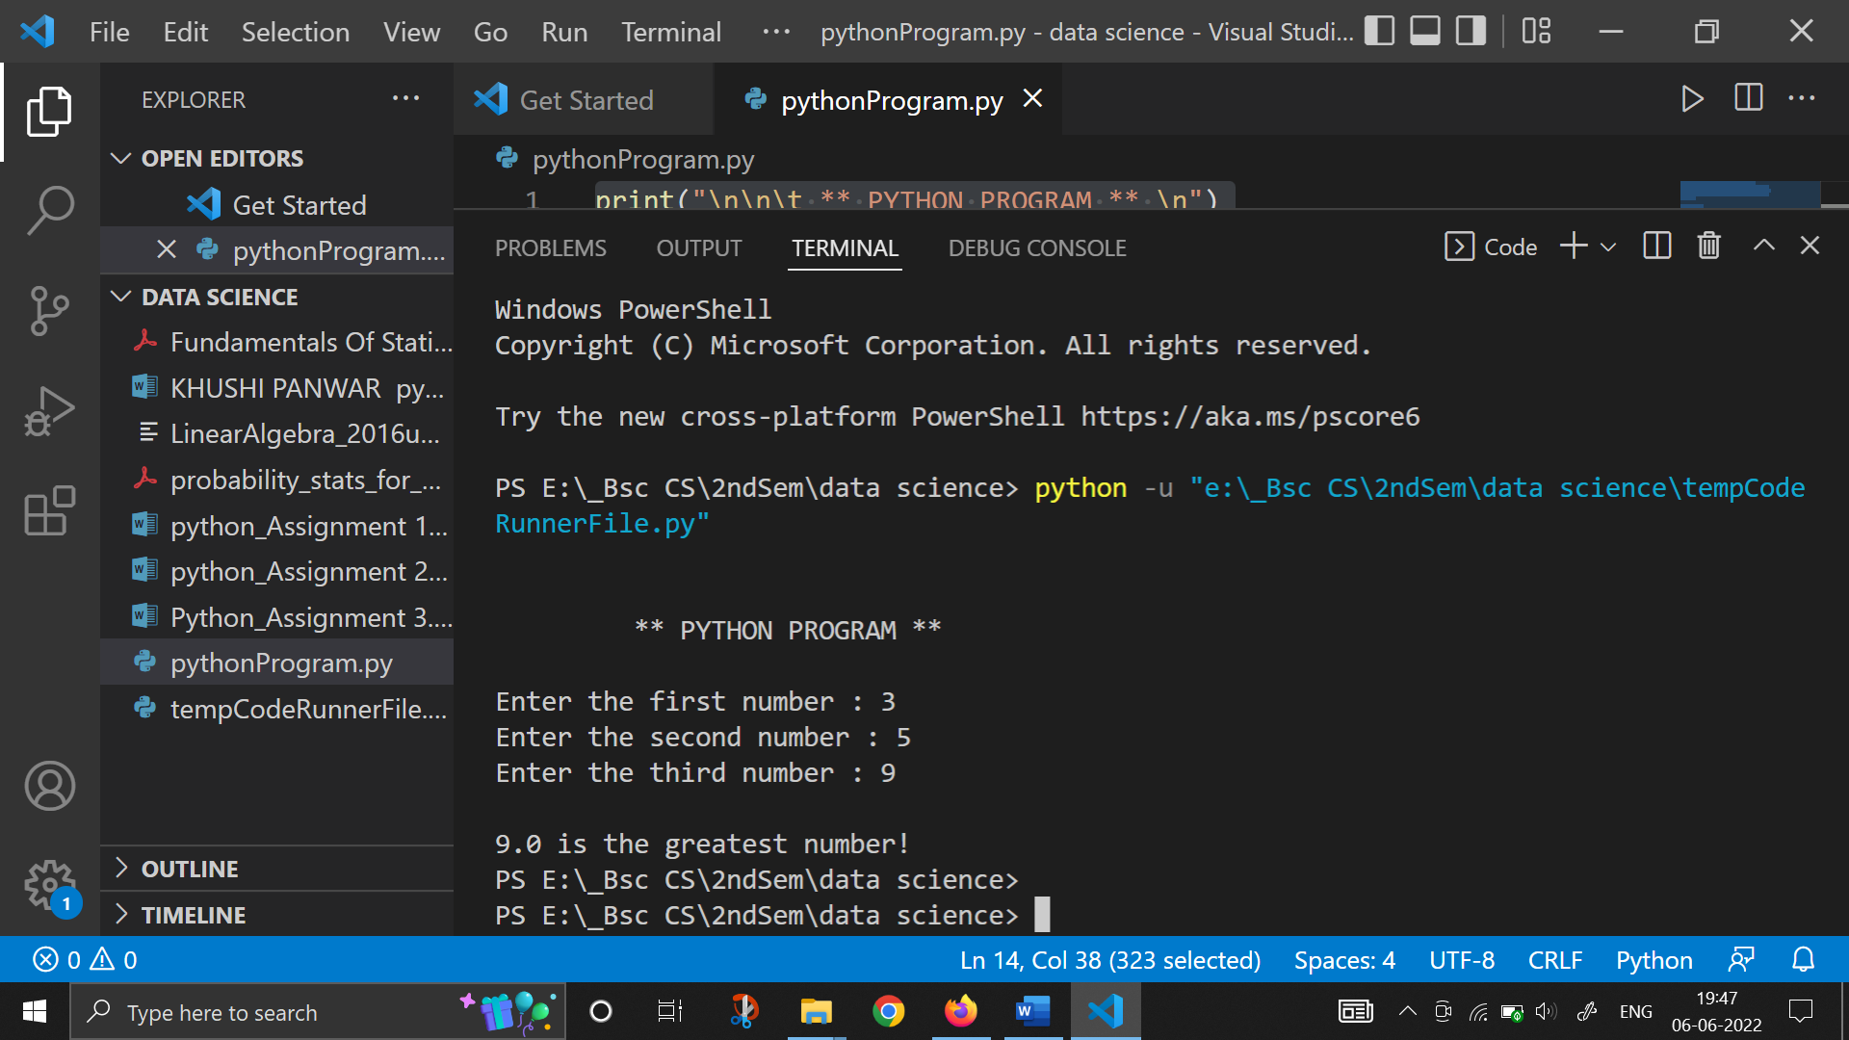

1. **Write a PYTHON program to check whether a number is negative, positive or zero.**

print("\n\t ** PYTHON PROGRAM ** \n")

num=float(input("Enter the number : "))

if num>0:

    print(num, "is a positive number!")

elif num<0:

    print(num, "is a negative number!")

else:

    print(num, "is equal to zero!")

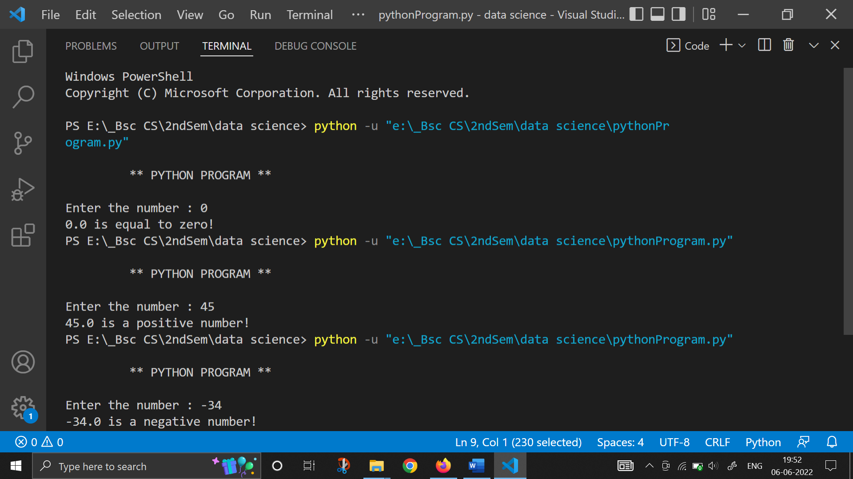

1. **Write a PYTHON program to check whether a number is divisible by 5 and 11 or not.**

print("\n\t ** PYTHON PROGRAM ** \n")

num=float(input("Enter the number : "))

if num%11==0 and num%5==0:

    print(num, "is divisible by 11 and 5")

else:

    print(num, "is not divisible by 11 and 5")

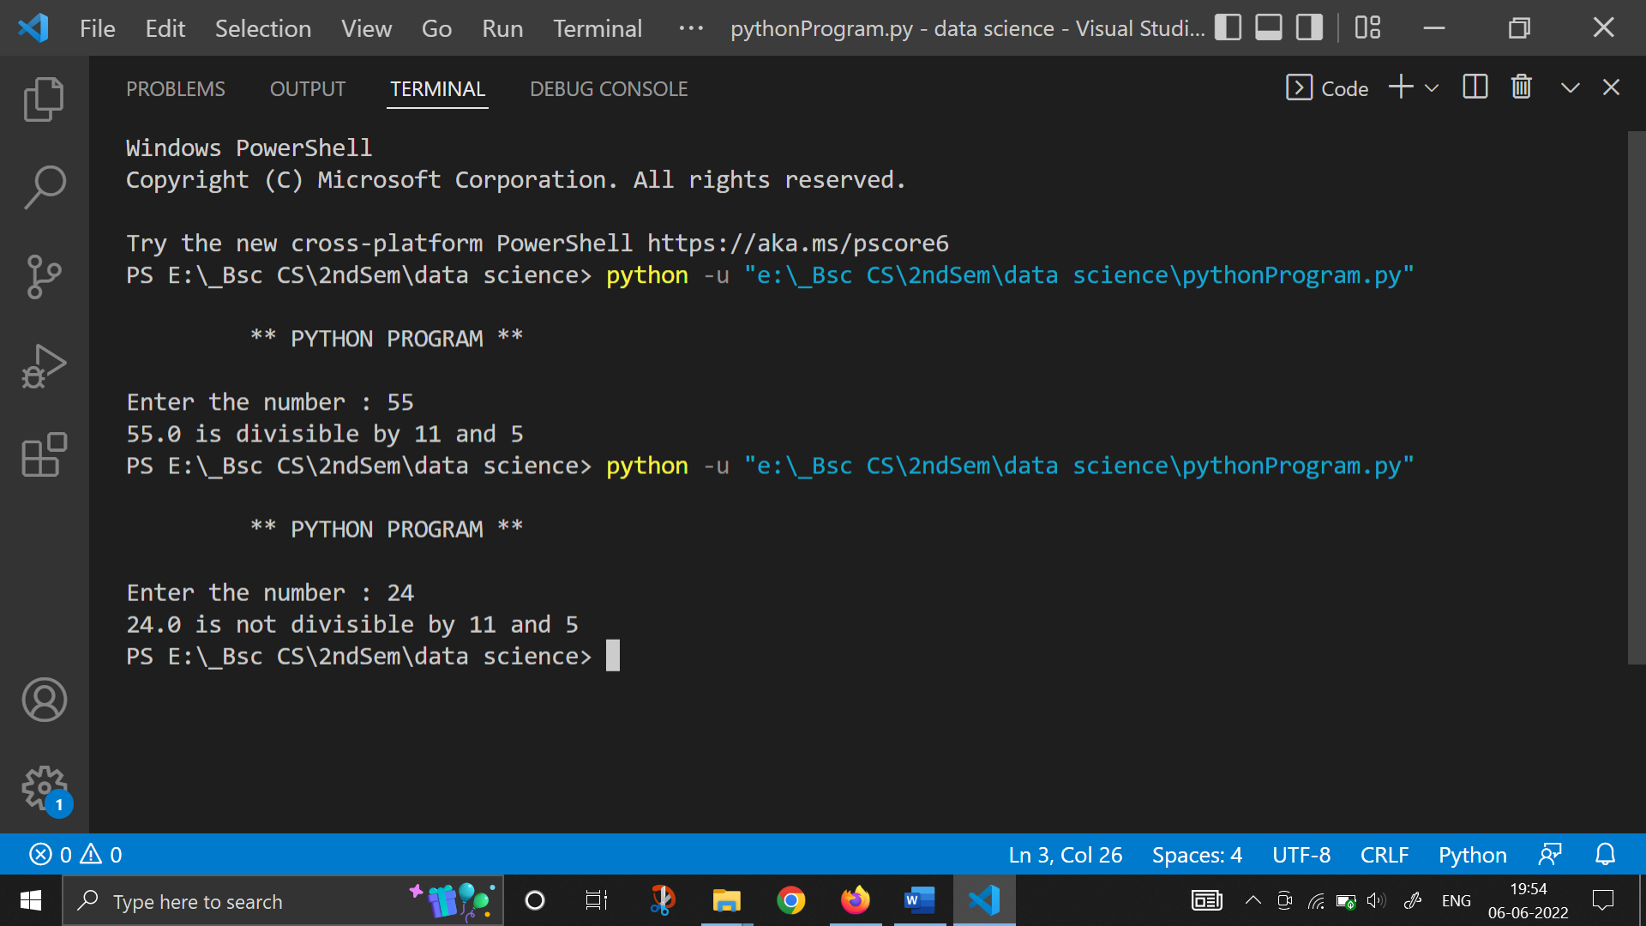

1. **Write a PYTHON program to check whether a number is even or odd.**

print("\n\t ** PYTHON PROGRAM ** \n")

num=float(input("Enter the number : "))

if num%2==0:

    print(num, "is even number")

else:

    print(num, "is odd number")

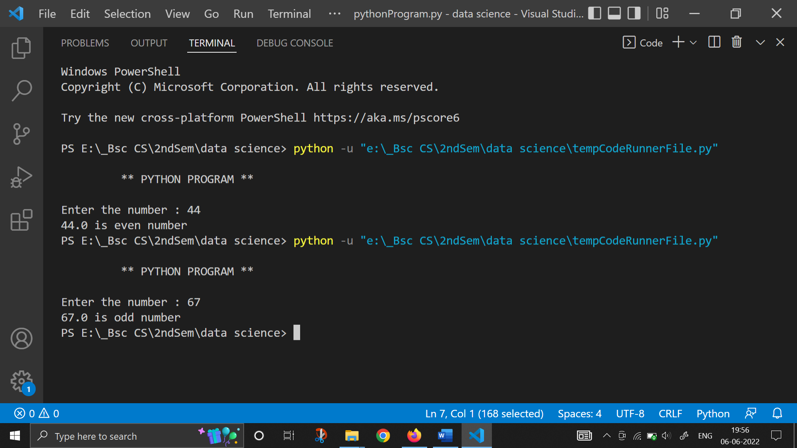

1. **Write a PYTHON program to check whether a number is leap year or not.**

print("\n\t ** PYTHON PROGRAM ** \n")

year=int(input("Enter the year : "))

if year%4==0:

    print(year, "is a leap year")

else:

    print(year, "is not a leap year")

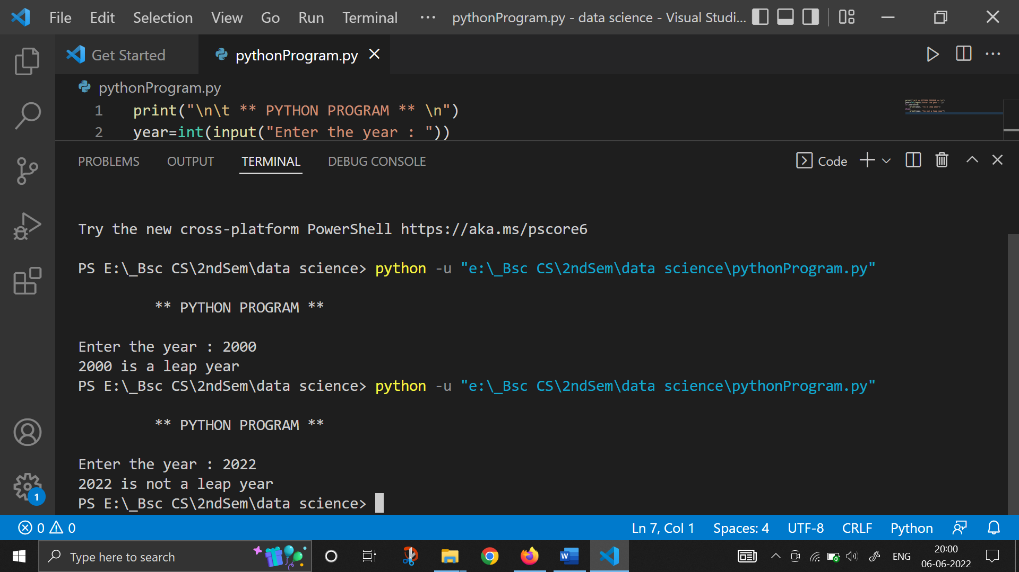

1. **Write a PYTHON program to check whether a number is alphabet or not.**

print("\n\t ** PYTHON PROGRAM **")

inp=input("Enter any character : ")

if inp>="a" and inp<="z":

    print(inp, "is an alphabet")

elif inp>="A" and inp<="Z":

    print(inp, "is an alphabet")

else:

    print(inp, "is not an alphabet")

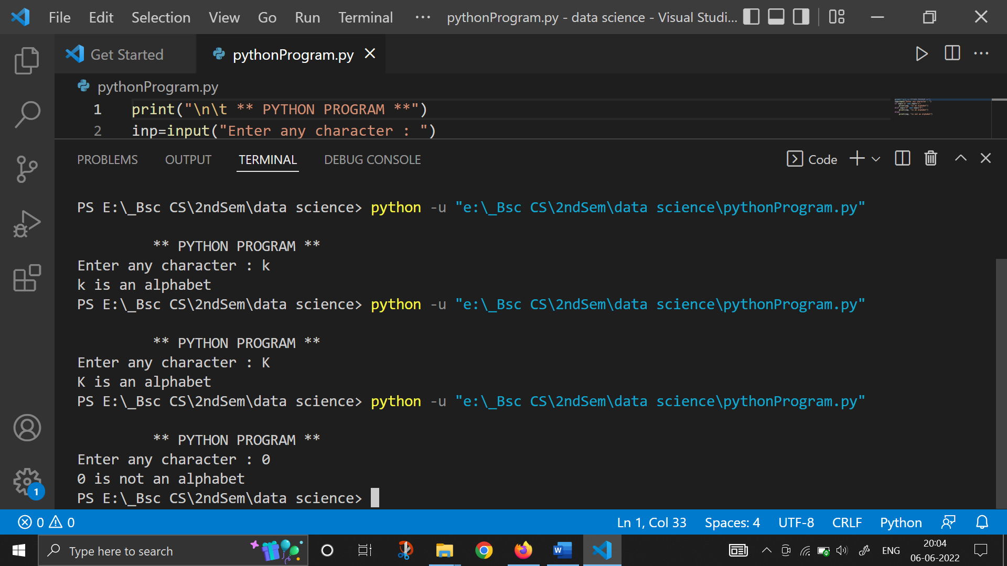

1. **Write a PYTHON program to check whether the input alphabet is a vowel or consonant.**

print("\n\t ** PYTHON PROGRAM **")

vowels=["a","e","i","o","u"]

inp=input("Enter any character : ")

if inp in vowels:

    print(inp, "is a vowel")

else:

    print(inp, "is a consonant")

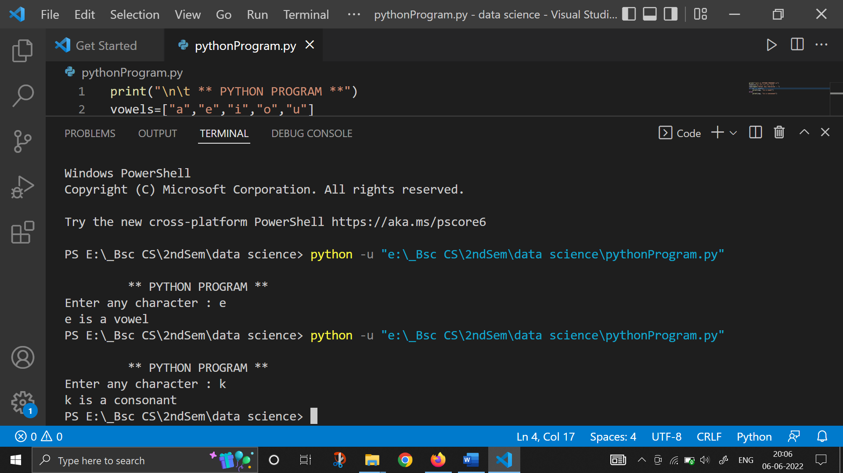

1. **Write a PYTHON program to check whether the input alphabet is an alphabet, digit or special character.**

print("\n\t ** PYTHON PROGRAM **")

i=0

while (i<5):

    inp=input("Enter any character : ")

    if inp>="a" and inp<="z":

        print(inp, "is an alphabet")

    elif inp>="A" and inp<="Z":

        print(inp, "is an alphabet")

    elif inp>="0" and inp<="9":

        print(inp, "is a number")

    else:

        print(inp, "is a special character")

    i+=1

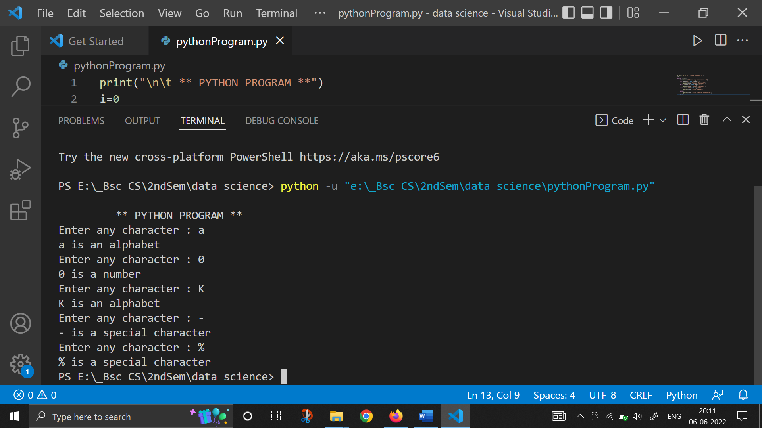

1. **Write a PYTHON program to check whether a character is uppercase or lowercase alphabet.**

print("\n\t ** PYTHON PROGRAM **")

i=0

while (i<3):

    inp=input("Enter any character : ")

    if inp>="a" and inp<="z":

        print(inp, "is a Lower case alphabet")

    elif inp>="A" and inp<="Z":

        print(inp, "is an Upper Case alphabet")

    else:

        print("INVALID CHARACTER")

    i+=1

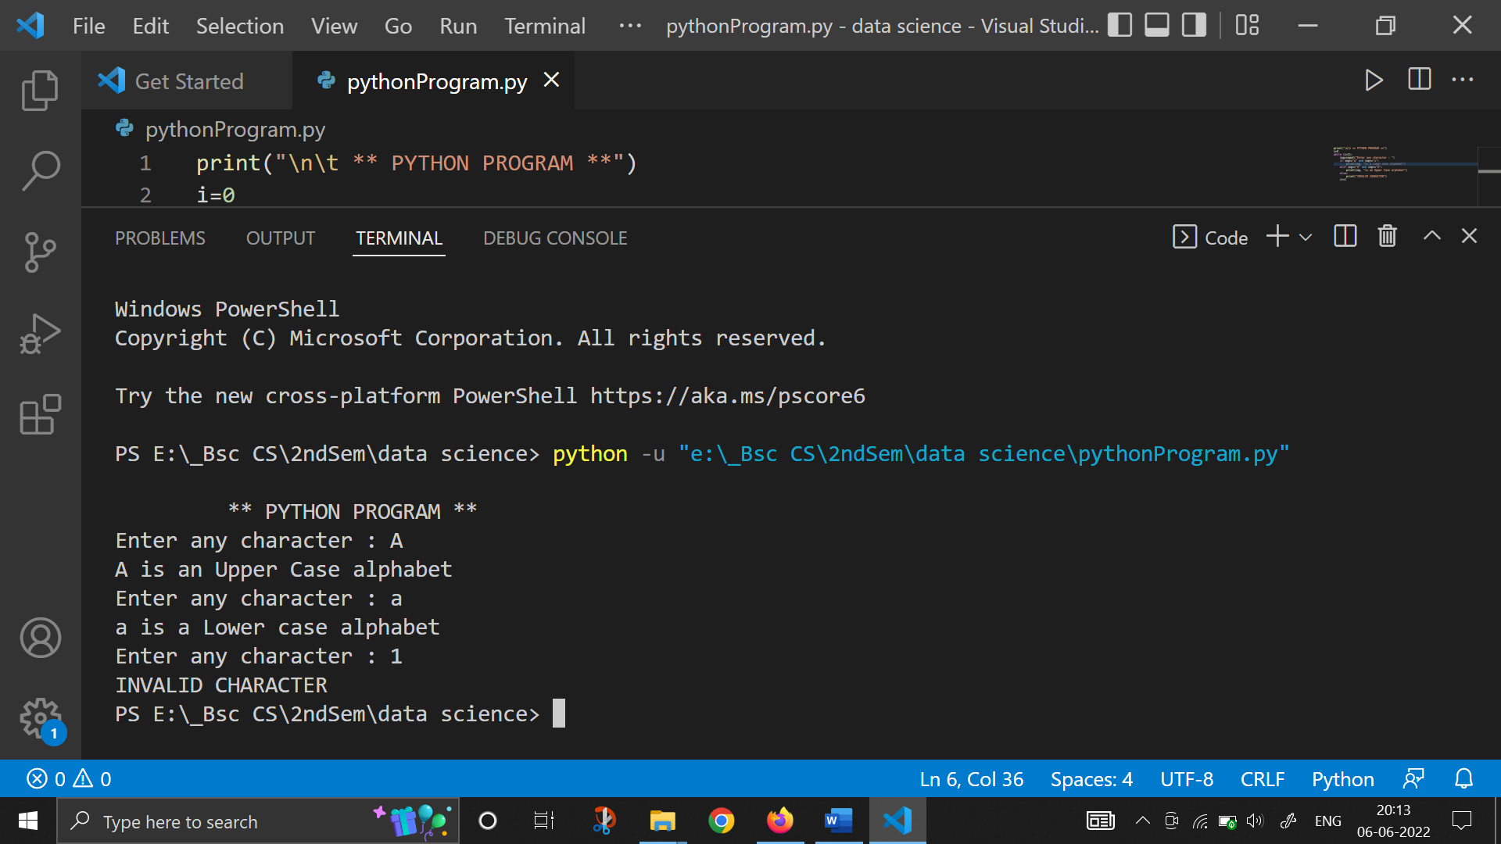

1. **Write a PYTHON program to input week day number and print week day.**

print("\n\t ** PYTHON PROGRAM **")

i=0

while (i<8):

    inp=int(input("Enter the week day : "))

    if inp==1:

        print("\t -> SUNDAY")

    elif inp==2:

        print("\t -> MONDAY")

    elif inp==3:

        print("\t -> TUESDAY")

    elif inp==4:

        print("\t -> WEDNESDAY")

    elif inp==5:

        print("\t -> THURSDAY")

    elif inp==6:

        print("\t -> FRIDAY")

    elif inp==7:

        print("\t -> SATURDAY")

    else:

        print("INVALID INPUT")

    i+=1

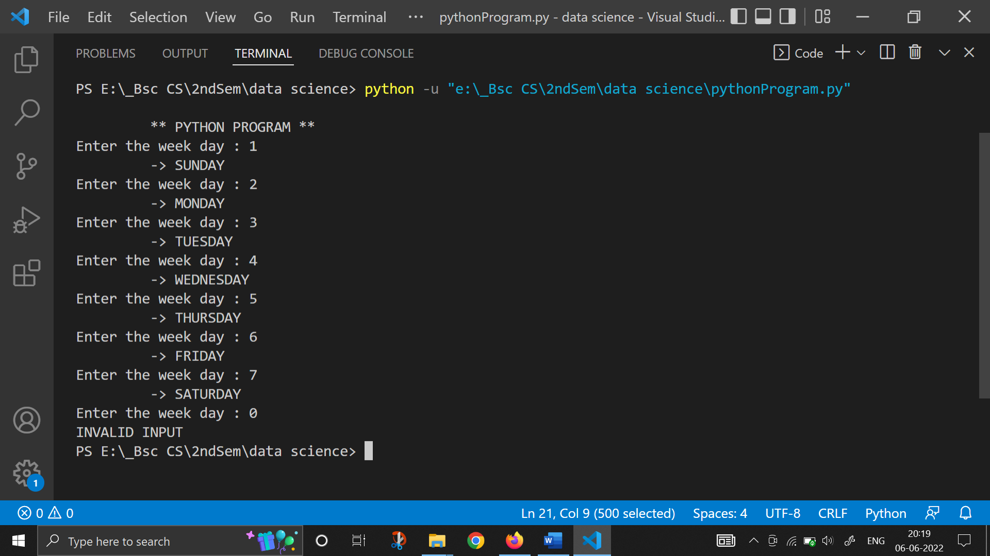

1. **Write a PYTHON program to input month number and print number of days in that month**

print("\n\t ** PYTHON PROGRAM **")

grp1=[1,3,5,7,8,10,12] #months with 31 days

grp2=[4,6,9,11] #months with 30 days

i=0

while (i<4):

    inp=int(input("Enter the month number : "))

    if inp in grp1:

        print("-> This month has 31 days")

    elif inp in grp2:

        print("-> This month has 30 days")

    elif inp==2:

        print("-> This month has 28 days")

    else:

        print("INVALID INPUT")

    i+=1

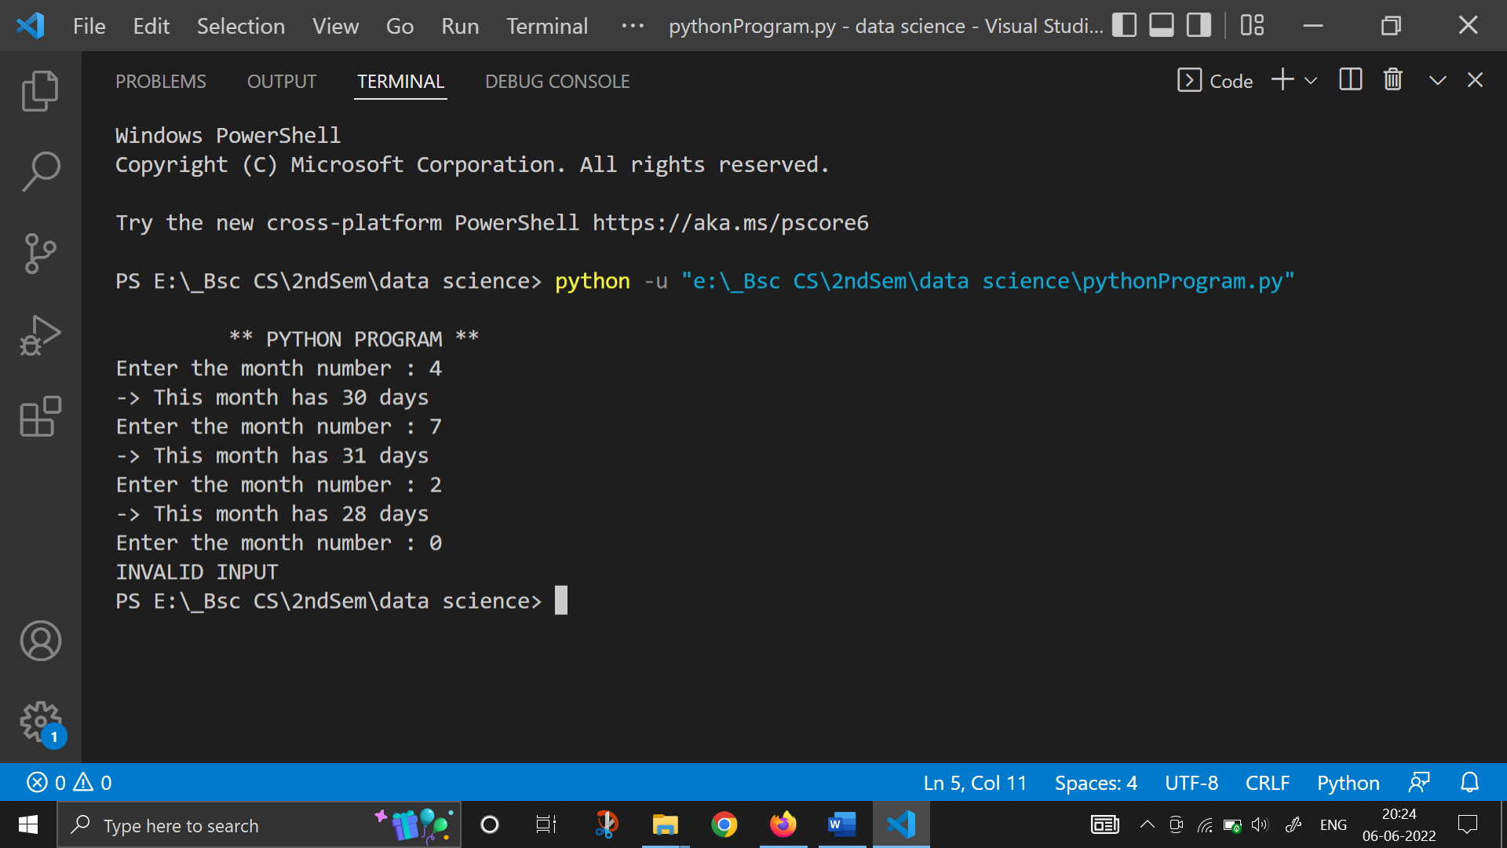

1. **Write a PYTHON program to count total number of notes in given amount.**
2. **Write a PYTHON program to input angles of a triangle and check whether triangle is valid or not.**

print()

a=float(input("Enter 1st Angle of Triangle : "))

b=float(input("Enter 2nd Angle of Triangle : "))

c=float(input("Enter 3rd Angle of Triangle : "))

if (a+b+c==180):

    print("\n\tThe Above Triangle is Valid!")

else:

    print("\n\tThe Above Triangle is Invalid!")

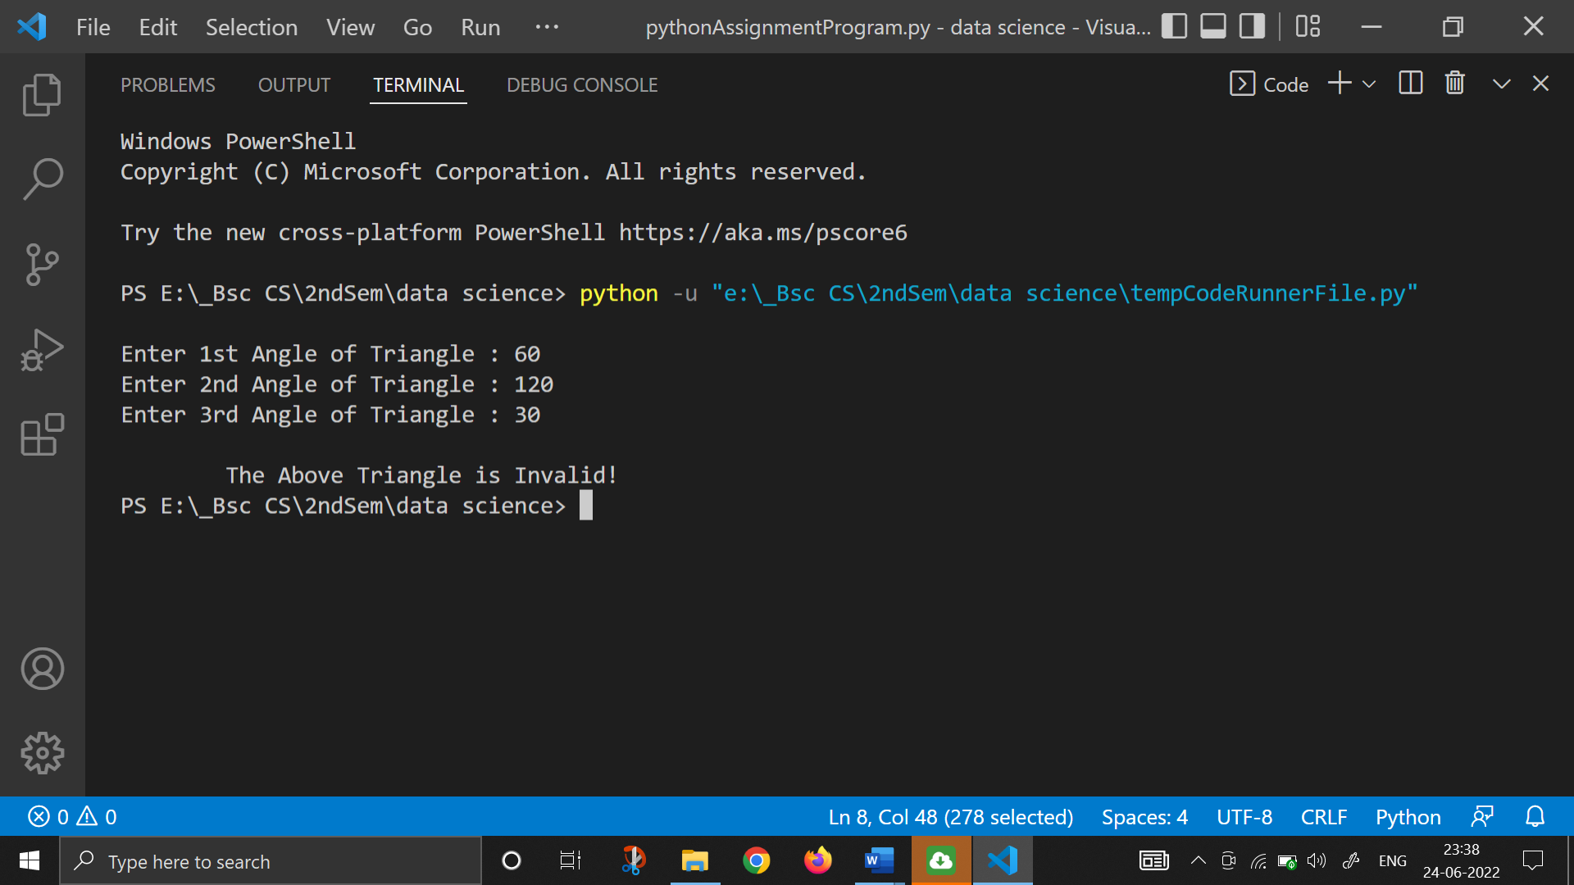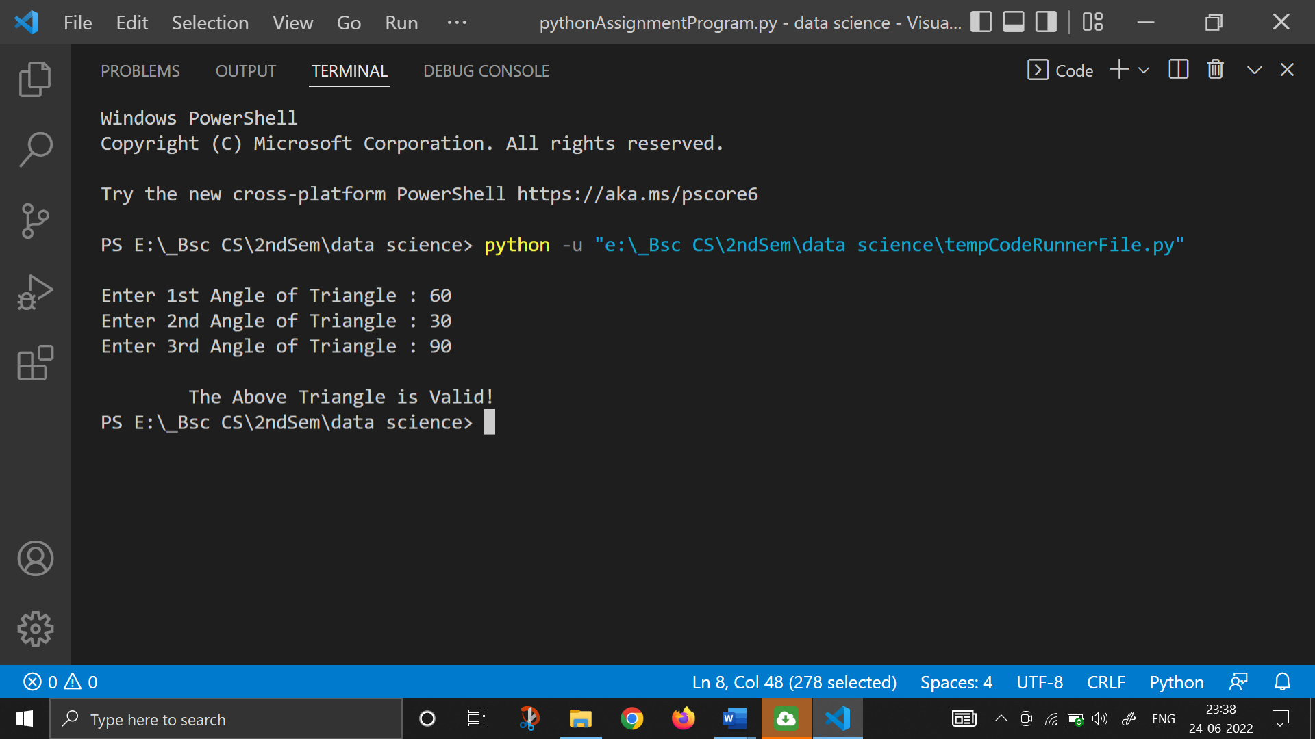

1. **Write a PYTHON program to input all sides of a triangle and check whether triangle is valid or not.**

i=0

while (i<3):

    print()

    a=float(input("Enter 1st Side of Triangle : "))

    b=float(input("Enter 2nd Side of Triangle : "))

    c=float(input("Enter 3rd Side of Triangle : "))

    if (b+c>a and b+a>c and a+c>b):

        print("\n\tThe Above Triangle is Valid!")

    else:

        print("\n\tThe Above Triangle is Invalid")

    i+=1

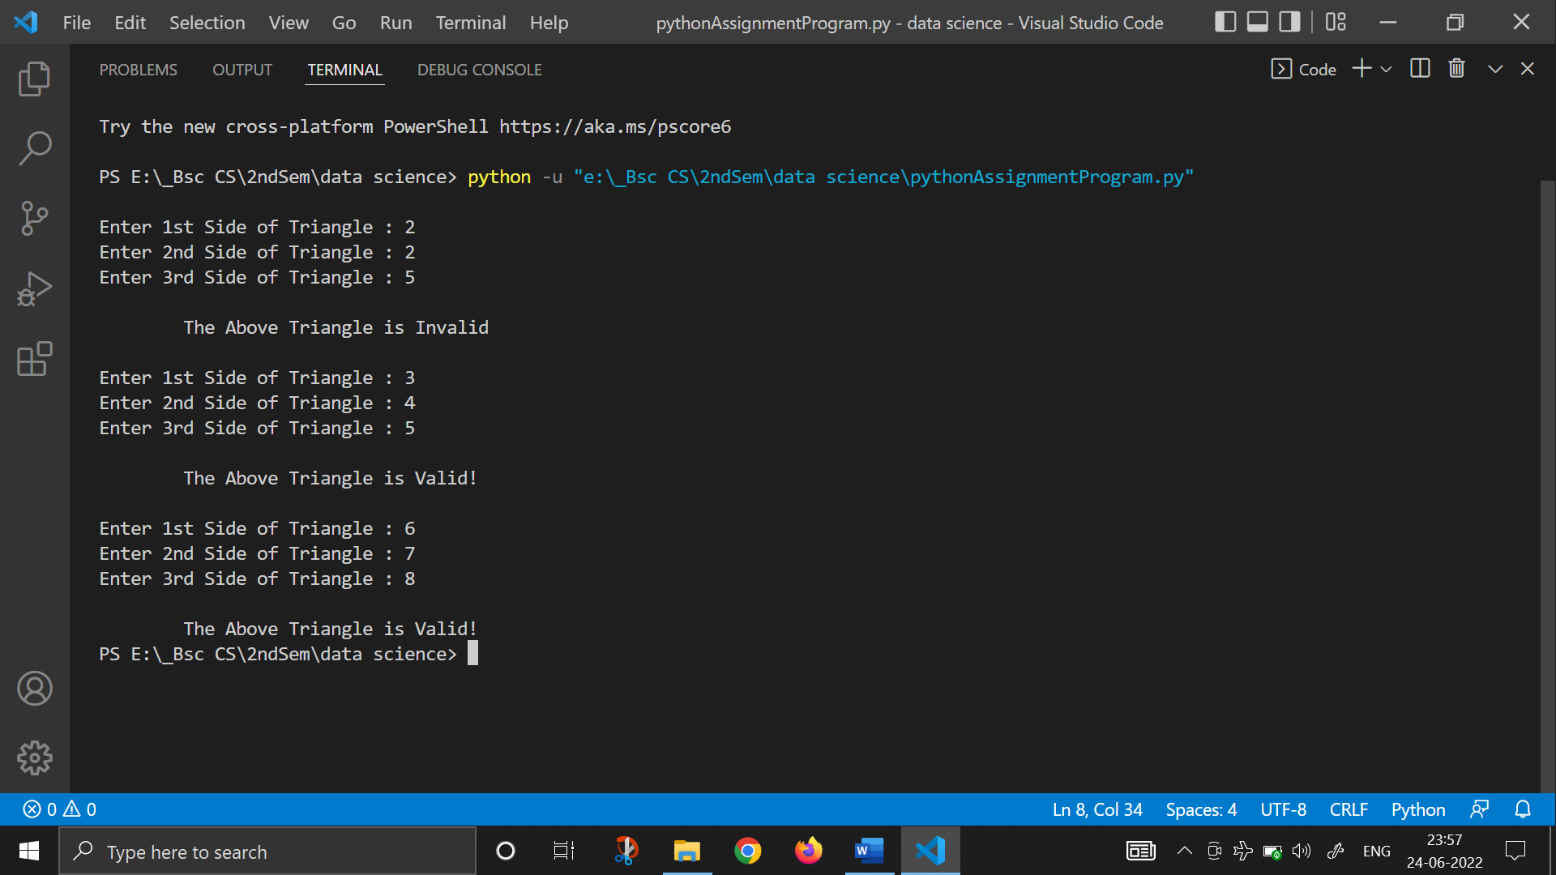

1. **Write a PYTHON program to check whether the triangle is equilateral, isosceles or scalene triangle.**

print()

i=0

while (i<3):

    a=float(input("Enter 1st Side of Triangle : "))

    b=float(input("Enter 2nd Side of Triangle : "))

    c=float(input("Enter 3rd Side of Triangle : "))

    if (a==b==c):

        print("\n\tThe Above Triangle is Equilateral!")

    elif (a==b or b==c or a==c):

        print("\n\tThe Above Triangle is Isosceles!")

    else:

        print("\n\tThe Above Triangle is Scalene!")

    i+=1

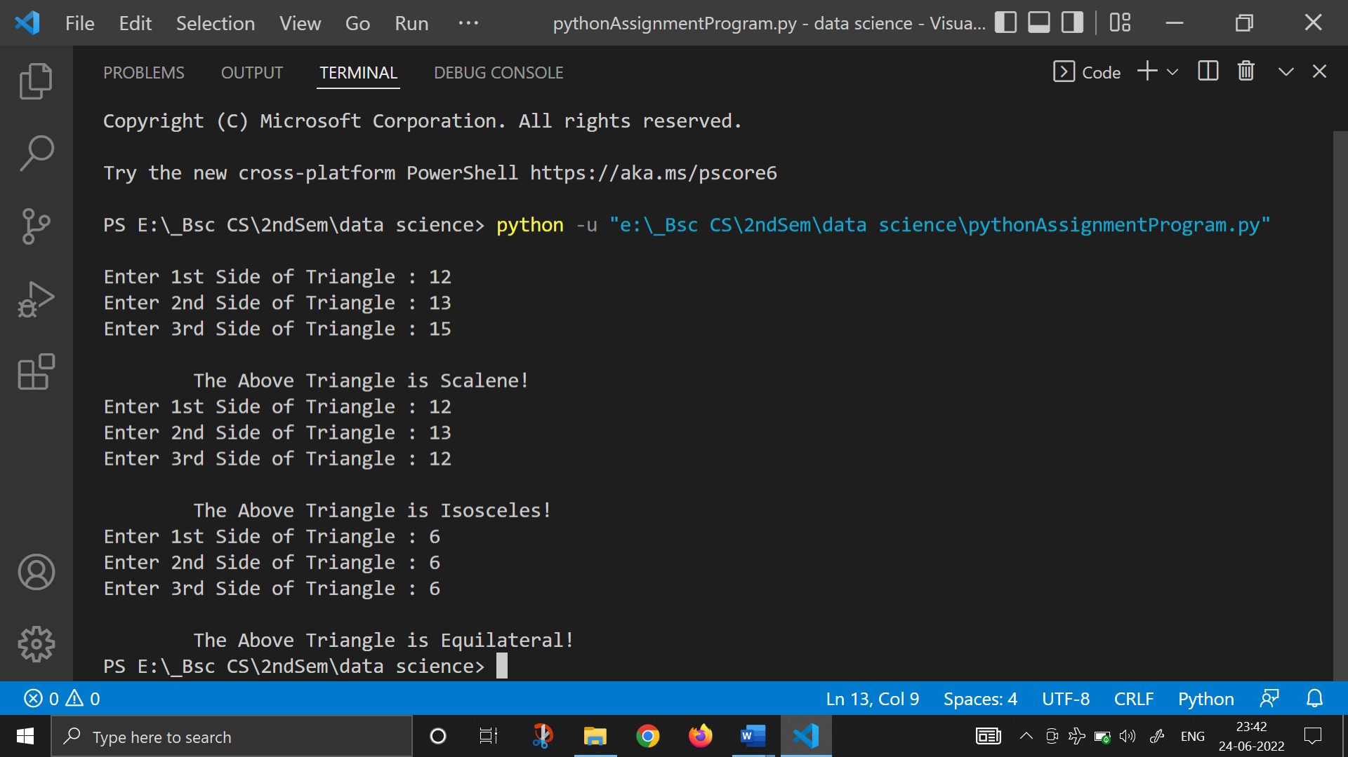

1. **Write a PYTHON program to find all roots of a quadratic equation.**
2. **Write a PYTHON program to calculate profit or loss.**
3. [Write a PYTHON program to input marks of five subjects Physics, Chemistry, Biology, Mathematics and Computer. Calculate percentage and grade according to following:](https://codeforwin.org/2015/05/c-program-to-enter-student-marks-and-calculate-percentage-and-grade.html)  
   Percentage >= 90% : Grade A  
   Percentage >= 80% : Grade B  
   Percentage >= 70% : Grade C  
   Percentage >= 60% : Grade D  
   Percentage >= 40% : Grade E  
   Percentage < 40% : Grade F

print()

i=0

while (i<3):

    phy=float(input("Enter the marks in Physics : "))

    chem=float(input("Enter the marks in Chemistry : "))

    math=float(input("Enter the marks in Maths : "))

    bio=float(input("Enter the marks in Biology : "))

    comp=float(input("Enter the marks in Computer : "))

    total=phy+chem+math+bio+comp

    prct=total/500*100

    if (prct>=90 and prct<=100):

        print("\n-> Grade A")

    elif (prct>=80 and prct<=90):

        print("\n-> Grade B")

    elif (prct>=70 and prct<=80):

        print("\n-> Grade C")

    elif (prct>=60 and prct<=70):

        print("\n-> Grade D")

    elif (prct>=40 and prct<=60):

        print("\n-> Grade E")

    elif (prct<40):

        print("\n-> Grade F")

    else:

        print("The Entered Marks are invalid, try again!")

    i+=1

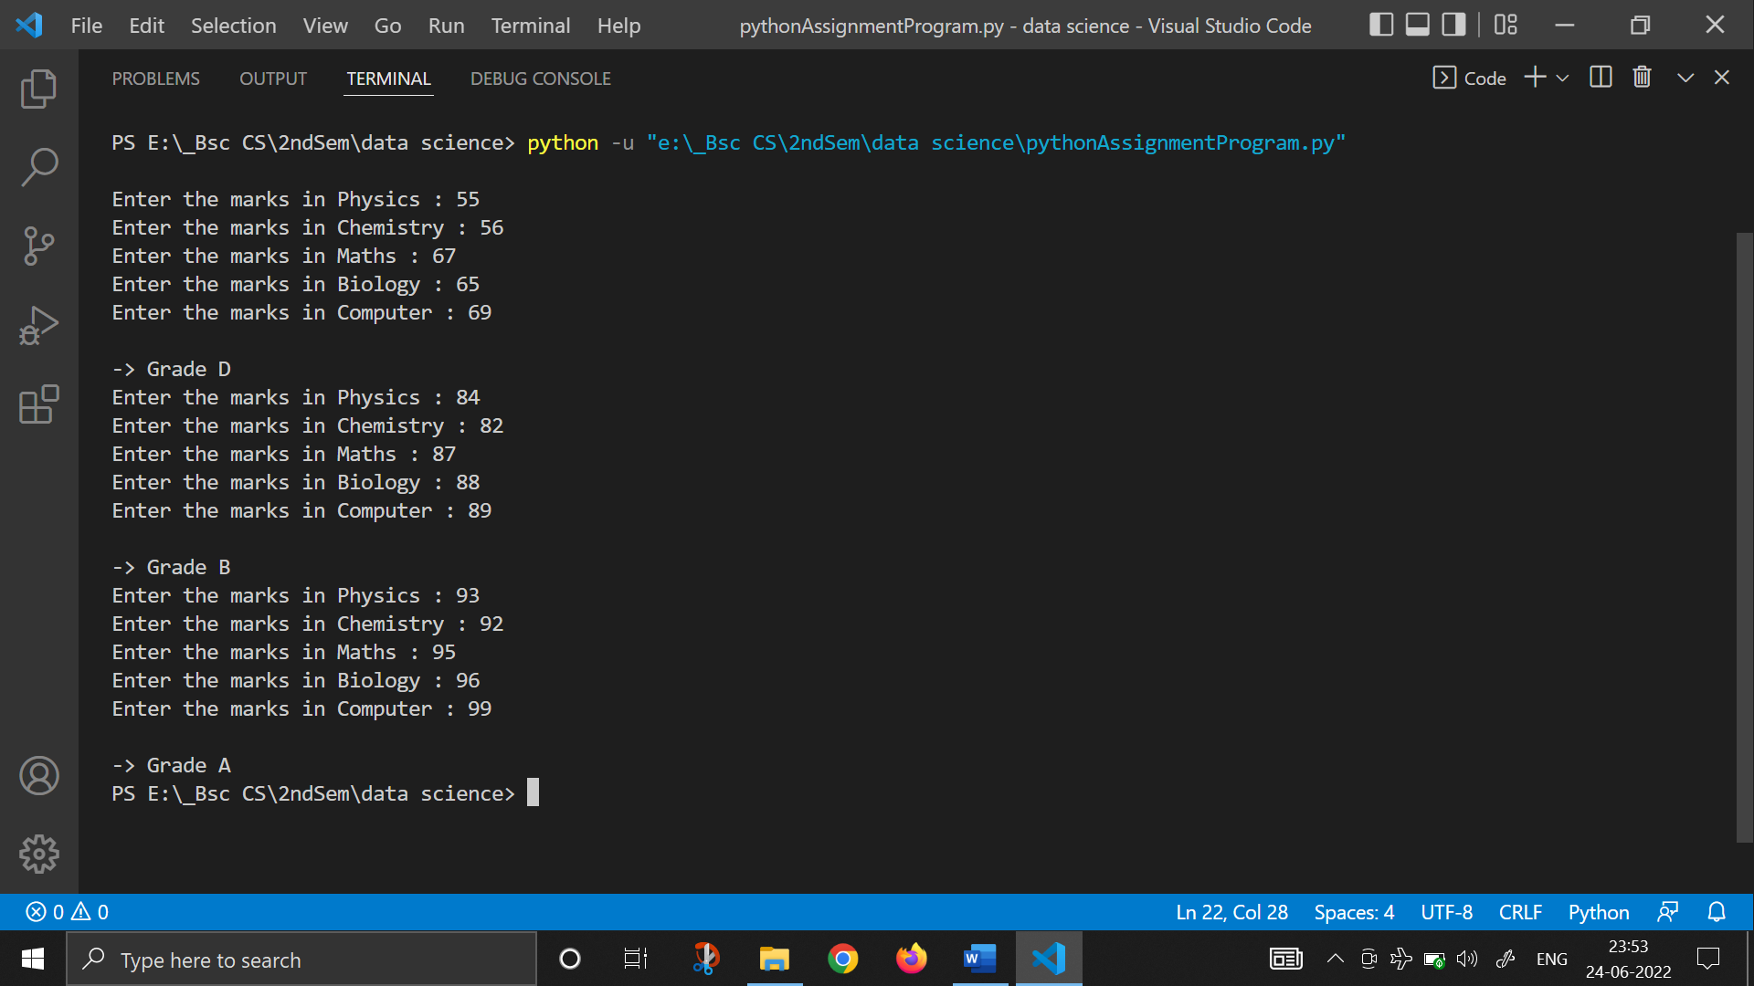

1. [Write a PYTHON program to input basic salary of an employee and calculate its Gross salary according to following:](https://codeforwin.org/2015/05/c-program-to-calculate-gross-salary-of-employee.html)  
   Basic Salary <= 10000 : HRA = 20%, DA = 80%  
   Basic Salary <= 20000 : HRA = 25%, DA = 90%  
   Basic Salary > 20000 : HRA = 30%, DA = 95%
2. [Write a PYTHON program to input electricity unit charges and calculate total electricity bill according to the given condition:](https://codeforwin.org/2015/05/c-program-to-calculate-electricity-bill.html)  
   For first 50 units Rs. 0.50/unit  
   For next 100 units Rs. 0.75/unit  
   For next 100 units Rs. 1.20/unit  
   For unit above 250 Rs. 1.50/unit  
   An additional surcharge of 20% is added to the bill